Blog/Article on “Zomato Data Analysis: Your shortcut to budget-friendly global cuisine exploration.”

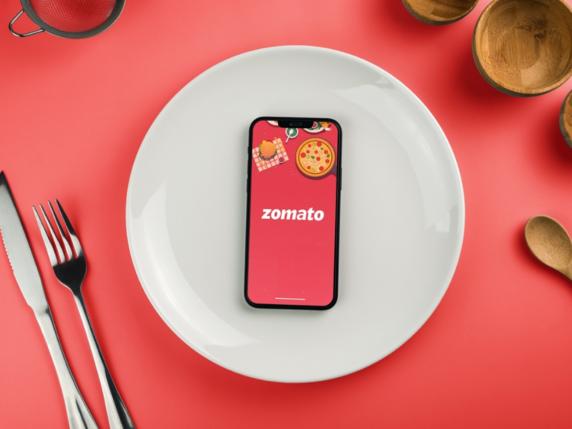 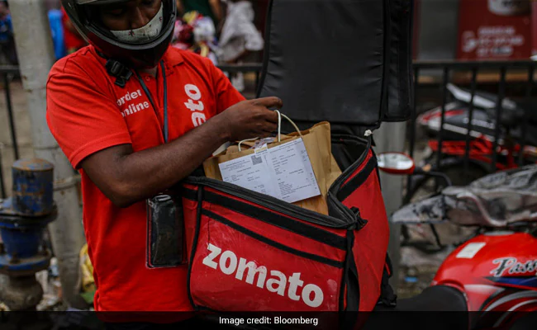

1. **Problem Definition:**

Description: The data analysed includes information on cuisine, costing, and customer reviews. The project aims to assist customers in finding the best restaurant in their locality and aid the company in identifying areas for growth and improvement in the industry. Additionally, the project aims to use the data for sentiment analysis and identifying critics in the industry through the metadata of reviewers.

Your go-to for budget-friendly global cuisine exploration, pinpointing value-for-money restaurants and top culinary hubs worldwide.to do this finding out following:

1) Average Cost for two

2) Price range

1. **Data Analysis:**

This problem statement contains two datasets- 1. **Zomato.csv** and 2. **country_code.csv.**

1. **Zomato.csv** :contains information about-

• Restaurant Id: Unique id of every restaurant across various cities of the world

• Restaurant Name: Name of the restaurant

• Country Code: Country in which restaurant is located

• City: City in which restaurant is located

• Address: Address of the restaurant

• Locality: Location in the city

• Locality Verbose: Detailed description of the locality

• Longitude: Longitude coordinate of the restaurant&#39;s location

• Latitude: Latitude coordinate of the restaurant&#39;s location

• Cuisines: Cuisines offered by the restaurant

• Average Cost for two: Cost for two people in different currencies ��

• Currency: Currency of the country

• Has Table booking: yes/no

• Has Online delivery: yes/ no

• Is delivering: yes/ no

• Switch to order menu: yes/no

• Price range: range of price of food

• Aggregate Rating: Average rating out of 5

• Rating color: depending upon the average rating color

• Rating text: text on the basis of rating of rating

• Votes: Number of ratings casted by people

**country_code.csv:** contains information about:

• Country code

• Country name

Target variables: Average cost for two and price range.

1. **EDA Concluding Remarks:**

* Merged Country-Code.csv and Zomato.csv files to access project.
* Checked and observe dataset details like columns, index, data types, missing or null values depicted by heatmap, duplicates.
* By analysing variables such as cuisine types, average costs, ratings, delivery, booking we gain a comprehensive understanding of dining patterns and preferences.
* Visualization highlights Zomato's strong grip on the Indian food business market by most used currency, rating, top 5 high and low average places etc. in comparison to its worldwide operations.
* Top of Form
* Bottom of Form
* we observe correlations between factors such as average cost, rating, and dining preferences, providing valuable insights for our subsequent modeling efforts.

1. **Pre-processing Pipeline:**

* Here, involves handling missing values, encoding categorical variables, and scaling numerical features.
* conducted feature engineering to extract relevant insights and enhance the predictive power of our models.
* Pre-processed data by detecting outliers, removing skewness, feature scaling for aimed prediction.

1. **Building Machine Learning Models:**

* on the task of building machine learning models to predict the average cost for two and the price range of restaurants. We explore various regression techniques, such as linear regression, random forest, and gradient boosting, KNeighbors Regressor to develop accurate predictive models.
* These models grasp features such as restaurant attributes, location data, and user ratings to make informed predictions.
* By selecting the Gradient Boosting Regressor as the optimal model, we have successfully achieved accurate predictions in our Zomato data analysis project.
* Top of Form
* Bottom of Form

**6.  Concluding Remarks:**

* In conclusion, our Zomato data analysis project offers a comprehensive understanding of the food industry. Using data science, we help people who love food to find what they're looking for. Whether it's finding great food that fits your budget or discovering new favourite places to eat in a new city, Zomato's data project is here to help. As we enjoy our success, let's keep exploring, being creative, and trying new things in the food world.

By:

Mrs. Mangal Reuben Adhav.

Batch : 2312.